**CS 576 – Assignment 1**

**Q.1**

Given:

Lines per frame = 450 lines/frame

Number of pixels per line = 520 pxl/line

Frame rate = 25Hz

Sampling scheme = 4:2:0 quantized with 8 bits

Average bits per pixel = (4*8 + 2*8 + 0)/4

=12

Pixels per frame = 450 * 520

= 23400

Bits per frame = 234000*12

= 2808000

* Bit rate = Sampling rate * Bits/Sample

= 25 * 2808000

= 70200000 bits per sec

= 70.2 Mbps

When Cr and Cb are quantized with 6 bits Average bits per pixel = (4*8 + 2*6 + 0)/4

= 2574000

Bit rate = 25 * 2574000

= 64350000 bits per sec

= 64.35 Mbps

* Minimum space on Hard disk required for 10 mins = 64350000 * 60 * 10

= (38610000000)/(8 * 1024 * 1024 * 1024)

= 4.494 GB

**Q.2**

By dividing the interval [4,-4] into 32 levels, we get:

|  |  |  |
| --- | --- | --- |
| 4.00 | 31 | 11111 |
| 3.75 | 30 | 11110 |
| 3.50 | 29 | 11101 |
| 3.25 | 28 | 11100 |
| 3.00 | 27 | 11011 |
| 2.75 | 26 | 11010 |
| 2.50 | 25 | 11001 |
| 2.25 | 24 | 11000 |
| 2.00 | 23 | 10111 |
| 1.75 | 22 | 10110 |
| 1.50 | 21 | 10101 |
| 1.25 | 20 | 10100 |
| 1.00 | 19 | 10011 |
| 0.75 | 18 | 10010 |
| 0.50 | 17 | 10001 |
| 0.25 | 16 | 10000 |
| 0.00 | 15 | 01111 |
| -0.25 | 14 | 01110 |
| -0.50 | 13 | 01101 |
| -0.75 | 12 | 01100 |
| -1.00 | 11 | 01011 |
| -1.25 | 10 | 01010 |
| -1.50 | 9 | 01001 |
| -1.75 | 8 | 01000 |
| -2.00 | 7 | 00111 |
| -2.25 | 6 | 00110 |
| -2.50 | 5 | 00101 |
| -2.75 | 4 | 00100 |
| -3.00 | 3 | 00011 |
| -3.25 | 2 | 00010 |
| -3.50 | 1 | 00001 |
| -3.75 | 0 | 00000 |

* **xq(n) = Q[xs(n)]**

Here Q is the rounding function that maps continuous values xs(n) to the nearest digital value xq(n) using b bits. Let b = 5, to represent 32 uniformly distributed levels.

The quantized values for the sample sequence are as below:

|  |  |
| --- | --- |
| **Sampled values** | **Quantized values** |
| 1.8 ~= 1.75 | 10110 |
| 2.2 ~= 2.25 | 11000 |
| 2.2 ~= 2.25 | 11000 |
| 3.2 ~= 3.25 | 11100 |
| 3.3 ~= 3.25 | 11100 |
| 3.3 ~= 3.25 | 11100 |
| 2.5 | 11001 |
| 2.8 ~= 2.75 | 11010 |
| 2.8 ~= 2.75 | 11010 |
| 2.8 ~= 2.75 | 11010 |
| 1.5 | 10101 |
| 1.0 | 10011 |
| 1.2 ~= 1.25 | 10100 |
| 1.2 ~= 1.25 | 10100 |
| 1.8 ~= 1.75 | 10110 |
| 2.2 ~= 2.25 | 11000 |
| 2.2 ~= 2.25 | 11000 |
| 2.2 ~= 2.25 | 11000 |
| 1.9 ~= 2.0 | 10111 |
| 2.3 ~= 2.25 | 11000 |
| 1.2 ~= 1.25 | 10100 |
| 0.2 ~= 0.25 | 10000 |
| -1.2 ~= -1.25 | 01010 |
| -1.2 ~= -1.25 | 01010 |
| -1.7 ~= -1.75 | 01000 |
| -1.1 ~= -1.0 | 01011 |
| -2.2 ~= -2.25 | 00110 |
| -1.5 | 01001 |
| -1.5 | 01001 |
| -0.7 ~= -0.75 | 01100 |
| 0.1 ~= 0.0 | 01111 |
| 0.9 ~= 1.0 | 10011 |

* We need 5 bits for each value

Hence 5 * 32 = 160 bits

**Q.3**

Given:

Speed of car = 36 km/hr

Frame rate = 24 frames/sec

Diameter of tire = 0.4244 meters

Distance traveled in 1 sec = 36 * 1000/(60 * 60)

= 10 m/s

* Number of rotations per sec = 10/(3.14 * 0.4244)

= 7.5 rotations/sec

When sampling rate is reduced to 12 frames per sec:

Since 12 fps is less than (2 * 7.5), we will have a negative effect

Number of rotations per second = 7.5 – 12

= -4.5 rotations/sec (tire rotation is seen in reverse)

**Analysis Questions:**

**Q1.**

We can see the change in the quality of the image as we vary the Y, U and V values.

The following are the observations plotted in a graph according to the perceptive changes seen as we vary one of the subsampling extent for Y, U and V with the other two constant at 1. The y-axis represents the perceptive decrease in Quality of the image. The x-axis values are the extent of subsampling. The following graph is plotted with the observations made with the provided image1.rgb.

**Keeping U and V constant at 1 and varying Y:**

The image quality deteriorates rapidly as sampling extent of Y increases. The image starts to become completely unacceptable after Y=4. As the quality decreases, the colors pink and light blue increase in the image.

**Keeping Y and V constant at 1 and varying U:**

The image quality deteriorates very slightly as sampling extent of U increases. The image starts to become unacceptable after Y=4 very gradually (but the image is recognizable). As the quality decreases, the colors pink and yellow increase in the image.

**Keeping Y and U constant at 1 and varying V:**

The image quality deteriorates rapidly as sampling extent of V increases. The image starts to become completely unacceptable after Y=3. As the quality decreases, the colors violet and orange increase in the image.

The following graph shows how the image quality decreases with the change of Y, U and V values. The quality decrease has been given values according to the visual perception of an individual.

When the same test cases are executed for provided image2.rgb, the decrease in image quality is seen much rapidly compared to image1.rgb.

**Q2.**

One of the ways to improve the quality of the image as observed by my experiments to be by changing the method of upsampling.

Initially the upsampling done was with the logic of averaging the two adjacent pixels on either side.

Subsampled pixel value(Upsampling) = (pixel value of previous pixel + pixel value for following pixel)/2;

I observed that by upsampling this subsampled pixel with following logic gave me better results which can be seen in the following image.

Subsampled pixel value(Upsampling) = pixel value of previous pixel;

The following images were recorded for the subsampling values of Y=2, U=2, V=2 and Q=256:

Image1.rgb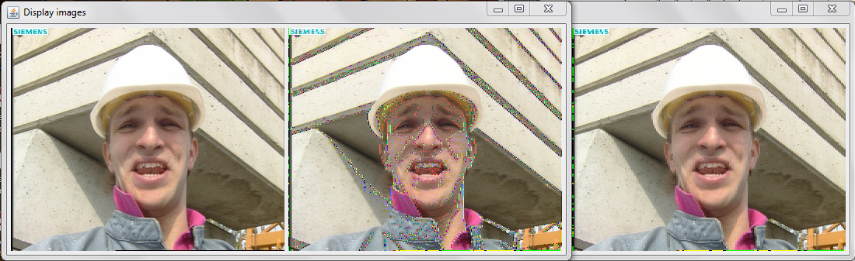

Image2.rgb

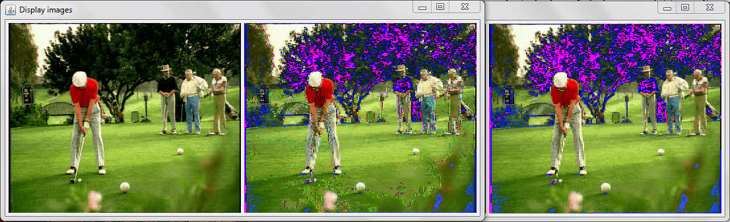

*The first image is the given rgb image. The second image is after upsampling by averaging. The third image is after upsampling by new code.

The following images were recorded for the subsampling values for Y=5, U=5, V=5 and Q=256:

Image1.rgb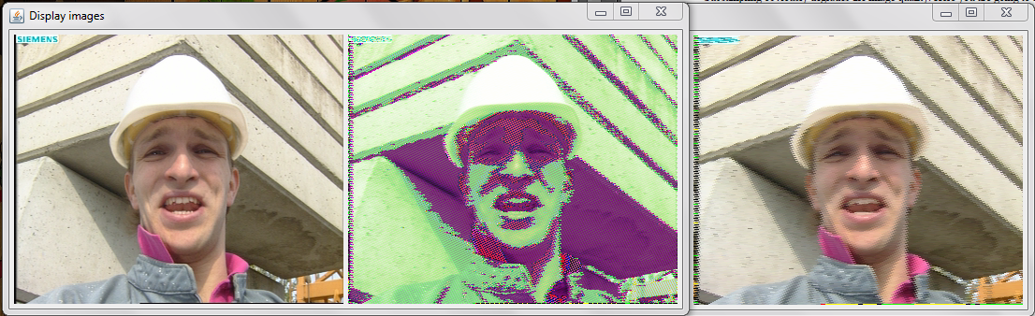

Image2.rgb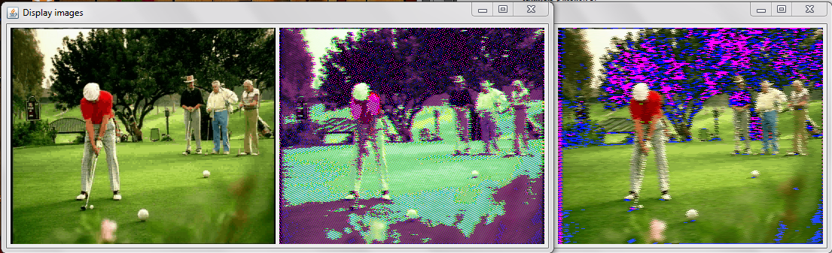

*The first image is the given rgb image. The second image is after upsampling by averaging. The third image is after upsampling by new code.